Elsworth
Cambridge
CB23 4
Planning and New Communities
South Cambridgeshire District Council
South Cambridgeshire Hall
Cambourne Business Park
Cambourne
Cambridge
CB23 6EA
26th January 2018
Dear Sir/Madam,
Objection to development on Land at Meadow Drift S/4550/17/FL
I strongly object to the proposed development on Land at Meadow Drift (S/4550/17/FL). This application contravenes a significant number of planning policies, will fundamentally alter the rural nature of Elsworth village, and, due to local flooding, is a wholly inappropriate site for development. After careful consideration, the Parish Council have also objected to this development.
My material objections are:
The lack of an agreed Local Plan does not allow the developers to ignore planning policy
The developers recognise that the development is contrary to planning guidelines, but wish to exploit the lack of an agreed Local Plan, to quote the application documents “The site is located outside of the village framework of Elsworth, however, given the District’s current housing land supply position, officers recognise that the scheme will make an important contribution towards housing supply in a reasonably sustainable location.”
- However, there is no housing shortfall: the housing supply land update from November 2017 for Cambridge and South Cambs clearly states that the South Cambs Annual Monitoring report for 2017 would show a more than significant housing supply above and beyond the housing growth requirements.
- The Local Plan is very close to being agreed and therefore planning policy should be followed: the National Planning Policy Framework is very explicit “216. From the day of publication, decision-takers may also give weight to relevant policies in emerging plans according to: the stage of preparation of the emerging plan (the more advanced the preparation, the greater the weight that may be given);” as the Local Plan is weeks from being finalised, the planners should act as if the Local Plan has been agreed and apply all relevant planning policies.
The development contravenes numerous planning policies
- South Cambridgeshire Local Development Framework Core Strategy
The core strategy has clearly defined objectives including
ST/j To ensure that the district's built and natural heritage is protected and that new development protects and enhances cherished townscape assets of local urban design, cultural, and conservation importance, and character of the landscape.
ST/k To locate development where it will ensure maximum use of previously developed land and minimise loss of countryside and the best and most versatile agricultural land.
The proposed development does not meet these objectives as it will:
- fundamentally alter the character of the edge of the village and its relationship with the surrounding rural environment; the view of the village/conservation area from Rogues Lane will become a housing development rather than hedges, trees, with glimpses of buildings;
- utilise grade 2 arable land for new dwellings and allotments, and transfer the current green allotment space into a large car parking area.
- South Cambridgeshire Local Development Framework Core Strategy POLICY ST/6 Group Villages
Elsworth is defined as a Group Village. ST/6 clearly states that “Residential development and redevelopment up to an indicative maximum scheme size of 8 dwellings will be permitted within the village frameworks of Group Villages, as defined on the Proposals Map.
A development of any scale on the proposed site contravenes the policy as it is not in the village framework. The dwellings and new allotments on the proposed development would be on existing arable land.
Even if it was within the village framework the number of houses is significantly higher than the 8 allowed for greenfield development.

- Supplementary Planning Document - Development Affecting Conservation Areas (Adopted January 2009)
Whilst the proposed development is not inside the Elsworth Conservation Area, Clause 1.10 makes it clear that “Development affecting Conservation Areas includes any development proposal outside the Conservation Area that would affect its setting, or views into or out of the area. The guidance contained in this SPD should be applied equally to any such development proposals.”
The village character, typical of rural villages, is predominantly of linear developments of housing along the roads with limited, if any, backfill. The properties along Broad End are predominantly set quite close to the road, with large rear gardens. The proposed development is a cul-de-sac backfill development of relatively high density with small/modest gardens and out of character with the surrounding properties in the conservation area.

The main playing field at Elsworth Primary School provides a gap in the street scene that provides visibility out into fields behind the school and is a key element of the rural character of Broad End and the Primary School. Ivyfold, a listed building directly opposite the school field, has sight lines across the school field, and a number of the listed properties located on the western side of Broad End have land to the rear of the properties that looks out across the proposed development site.

The proposed development would completely change the character of Broad End: current site lines that emphasise the rural character would now look into a housing development. At the corner of Fardells Lane and Broad End, the road into the development would look directly into a large car park rather than the current allotments.

The large car park is in itself completely at odds with the rural nature of the village and the surrounding conservation area.

When viewed from Rogues Lane there is currently little visibility of the houses running down Broad End, the rhythm and pattern of buildings where visible is typically rural. Under this proposal and the associated landscaping, the edge of the village as viewed from Rogues Lane will now be defined by a small cul-de-sac with relatively high density building separated from the surrounding countryside by low hedges, that will not hide the allotment car park, this is completely out of character with the village and conservation area. It would result in considerable encroachment of the built development into the gentle rolling topography of the village and would change the rural character of this approach to the village.

- Development Control Policy DP/1 Sustainable Development and DP/3 Development Frameworks
Under DP/1 “Development will only be permitted where it is demonstrated that it is consistent with the principles of sustainable development, as appropriate to its location, scale and form. It should:”…”i. Minimise flood risk;”.
Under DP/3 “Planning permission will not be granted where the proposed development would have an unacceptable adverse impact:”…”2. l. On village character; m. On the countryside, and landscape character; p. On flooding and flood risk; q. On the best and most versatile agricultural land;”

Regarding DP/1 : the developers have provided a desk based assessment of the flood risk associated with the new development. The risk assessment is fundamentally flawed for a number of reasons:
- The site regularly floods
The report claims that the risk of pluvial flooding for the site is 1 in 100 years, this is not reflective of the reality on the site and demonstrates that the developers are ignoring an issue with the site that is well known by the owner, the local community, the Parish Council, District Council and the Environment Agency.

Significant and/or persistent rain overcomes the current capacity of drainage ditches (including the ditch on the western boundary of the site) and culverts to manage the water running off the fields to the west of Broad End on a number of occasions every year. This is a significant and ongoing problem. As a result, Broad End floods on a number of occasions each year making access to the proposed development problematic.

In addition, and most significantly, there are occasions when the volume of water running off of the fields is so large, that it floods directly across the field to the west of Elsworth Primary school (i.e. the precise location for the proposed properties) and then across the school playing field and into Broad End.

To illustrate the issue, the appended images were taken on 27th December 2017 when water flooded across the development site, over the school playing field and onto Broad End. A modest amount of snow had fallen onto the already sodden ground; when the snow melted later in the day, the meltwater was sufficient to flood Broad End (picture 1) and Fardells Lane, but also flooded across the playing field of Elsworth Primary School and out of the school gate. Pictures 2 and 3 show the water flowing under the school gate into Broad End. In order for the flood water to cross the playing field (see picture 4), it had to come from flooding of the proposed site.

- The proposed approach to water management does not address the inherent flood risk and will increase existing flood risk
The development will create additional water run off issues, particularly the large car park, the proposed solution is to collect surface water on the site and pump it back up and into the ditches that already flood the site and cause flooding on Broad End and Fardells Lane.

- The development will prevent the implementation of existing flood alleviation proposals
An approach to reducing/eliminating the flooding issues on Broad End and Fardells Lane was agreed with the Environment Agency in January 2006. This plan has not been implemented to date as the Environment Agency wanted to put downstream flood alleviation plans in Fen Drayton in place. These downstream activities were only completed last year. This development would prevent the proposals for Elsworth being actioned.

Regarding DP/3: as outlined above the development will have a significant impact on the countryside and landscape character of the village and the development is on grade 2 agricultural land.
- POLICY DP/7 Development Frameworks
Clearly states that “Outside urban and village frameworks, only development for agriculture, horticulture, forestry, outdoor recreation and other uses which need to be located in the countryside will be permitted.” Furthermore it explicitly states that this is to “ensure that the countryside is protected from gradual encroachment on the edges of villages and to help guard against incremental growth in unsustainable locations.”
The proposed development:
- is outside the Elsworth Village Framework.
- is allowing the village to gradually encroach on the countryside.
- sets a precedent for further development on the edges of the village.
- is in an unsustainable village.

Other material considerations
- Land use
The proposed development includes 6 affordable houses (note that this is below the 40% affordable housing requirement for developments), however Elsworth does not have the amenities required to support effective use of affordable housing:
- Elsworth is not considered to be a sustainable location by the District Council and does not have enough services and amenities to make it sustainable.
- There are no medical facilities in the village; the nearest facilities that would be normally used by villagers are in Papworth (technically there is one available bus journey into Papworth, however the return bus leaves 4 minutes after arriving) and in Cambourne (no public transport access).
- The local transport links are minimal, which is demonstrated by the fact that only 1% of villagers used public transport to get to work in the census reports highlighted by the developer.

Given the issues with drains etc in the village, it is questionable whether the current sewerage system can cope with another 16 houses.
- Highway issues
There will be more vehicles than the developer’s assumptions
The assessment of vehicle movements provided by the developers appears to grossly underestimate the likely vehicle movements associated with the proposed houses. Their estimates are that an additional 9 movements would occur in the morning peak rush hour and 9 in the evening rush hour. Based on the census data used by the developer: of the 566 people resident in the survey, 202 went to work as a car driver, 9 went to work on a train, as a car is required to get to the train station, this implies a total of 211 people used a car to leave the survey area, i.e. 37% of the residents. Assuming an average of 3 people per household in the new development, this implies an additional 18 car movements leaving in the morning and returning in the evening and also excludes any vehicle movements associated with non-work related activities.
More simplistically, at present there are 19 properties that would naturally be accessed via Broad End. The proposed development will add a further 16 properties, almost doubling the amount of traffic. Due to the enormous increase in the use of Elsworth as a ‘rat run’ to avoid the Caxton Gibbet roundabout congestion and roadworks on the A14, existing residents are already finding it increasingly risky entering the main road from Broad End at peak commuter times; the new development will only further exacerbate this issue with additional vehicles turning onto a busy road with limited visibility.
The proposed school car park will not be effective
The developers have proposed a new car park alongside the primary school. Whilst the creation of the car park may be well intentioned, it is clear that the developers do not understand the parking issues on Broad End. Currently parents, dropping off or collecting children, park along the length of Broad End; all accessed from Broad End (vehicles are actively discouraged from using Fardells Lane to minimise the risk to children/parents using the lane to access school on foot). Typically around 50 vehicles enter and exit Broad End at each school drop-off/pick up on a dry day (more vehicles movements occur on wet days). A brief survey over 3 days has indicated a peak of ~40 cars on the lane.
Currently parents attempt to park as close to the school as they can. However, once a small number of cars have started parking along Broad End, it becomes increasingly difficult for subsequent vehicles to navigate around them. Once cars start to look to leave Broad End they struggle to turn around and once they do, often cannot get past the parked cars against the oncoming traffic. Meanwhile, the cars still entering Broad End struggle to progress against the vehicles now exiting.
The solution to many of these ‘roadblocks’ is for vehicles to use the grass verge to pass each other; over the years the verges have been gradually destroyed and reduced, whilst the road has effectively been widened. Broad End is being continually harmed by the existing traffic issues which will now be further increased by the traffic from the houses in the proposed development.
However, putting in place a car park does not solve this issue:
- the proposed car park does not have sufficient spaces to accommodate the peak number of cars that wish to park and access the school 30 spaces versus ~40 cars.
- as a result cars will continue to park along Broad End. There are no parking restrictions in place currently and it seems inappropriate to put parking restrictions in place that would also impact on residents and completely destroy the rural feel of the lane with yellow lines. If parking restrictions were to be imposed, it is not clear how they would be enforced. In addition removing all parked cars from Broad End will allow cars to move quicker down the lane and perversely actually place the children crossing the road at greater risk.
- placing the car park at the end of Broad End will only create more traffic that needs to go to the very end of the road and back struggling to pass the parked cars and cars going in the opposite direction.
I believe that the proposed car park will actually exacerbate rather than alleviate the traffic issues on Broad End at school pick up and drop off times. It would appear that the Highways Officer also appears to not be convinced, quoting from the application:
“3.10 Highways Officers indicated that they would need to be convinced that the proposed arrangement will result in desirable and beneficial outcomes, as opposed to encouraging further car use (and as a result, contributing to existing highways problems). It was noted that the strategy has been a ‘village driven’ initiative to address the existing traffic congestion issues associated with
the schools.
3.11 It was noted that the Local Highways Authority would be prepared to see a planning condition imposed that prevents development of this aspect of the overall scheme until such time that a satisfactory Travel Plan has been secured between the schools and the Local Education Authority. The condition may be worded in such a way as to allow the remainder of the scheme (housing and allotments) to come forward independent of the car park.” Furthermore there appears to be scope for the development to be approved in the hope that it will improve the traffic situation, but for the car park to never be built – or worse subsequently developed for further houses.
- Creating a planning precedent for development along Broad End and the other edges of the village
By developing to the rear of Elsworth Primary School the proposed development will start to redefine the edge of the village and its relationship with the surrounding countryside. Given that many of the existing properties to the west of Broad End and Meadow Drift have significant rear gardens, I believe that the development creates a dangerous precedent that will allow other properties to seek permission for backfill development on the same basis.

The subsequent developments could utilise access through the existing properties or indeed via the new access route that the new development would create. Once the western edge of the village has succumbed to this form of development, there is significant precedent for the remaining edges or undeveloped spaces in the village to follow suit. Ultimately, this development may lead to significant unplanned expansion of the village.
The proposed development combined with subsequent backfill applications would completely alter the character of Broad End and the edge of the village, a specific outcome that POLICY DP/7 is intending to avoid.
- Prevention of crime and disorder
The proposed car park and the turning circle/allotment parking will become the only significant hard standing ‘open’ space for vehicles to congregate within the village, it will be relatively secluded and I believe creates a significant potential for disorder that is not currently possible within Elsworth. Whilst it is proposed that lockable bollards will be put in place on the school car park, it is not clear how this will work in practise and furthermore it is questionable whether it will provide an effective deterrent to groups that are happy to use bolt cutters etc to find somewhere to put caravans as is frequently the case on other so called ‘secured’ sites.

In conclusion, there is no justification to ignore planning policies and to allow this significant development in Elsworth. SCDC planners must assess this application against all planning policies including those that the developers already agree they will be contravening. Given the significant contravention of planning policy, flood risk to the site and elsewhere, harm to the village setting from this and subsequent developments, SCDC cannot approve this development.
Yours faithfully

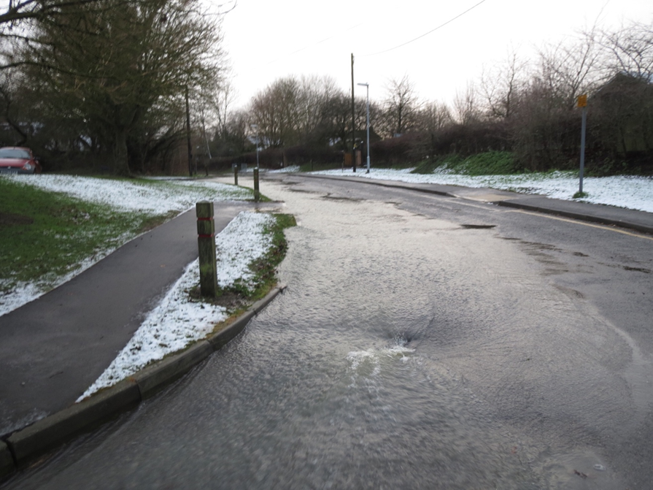
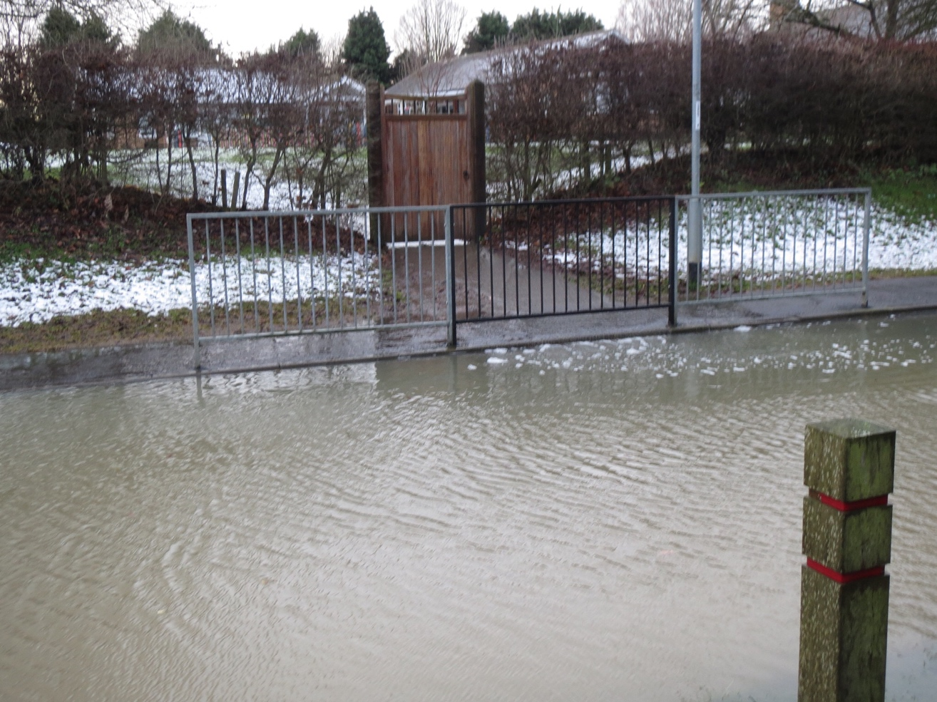
Appendix, photos taken 27th December 2017
Picture 1: View from corner of Fardells Lane and Broad End
Picture 2: Flooding in front of school, note flow from gate into road

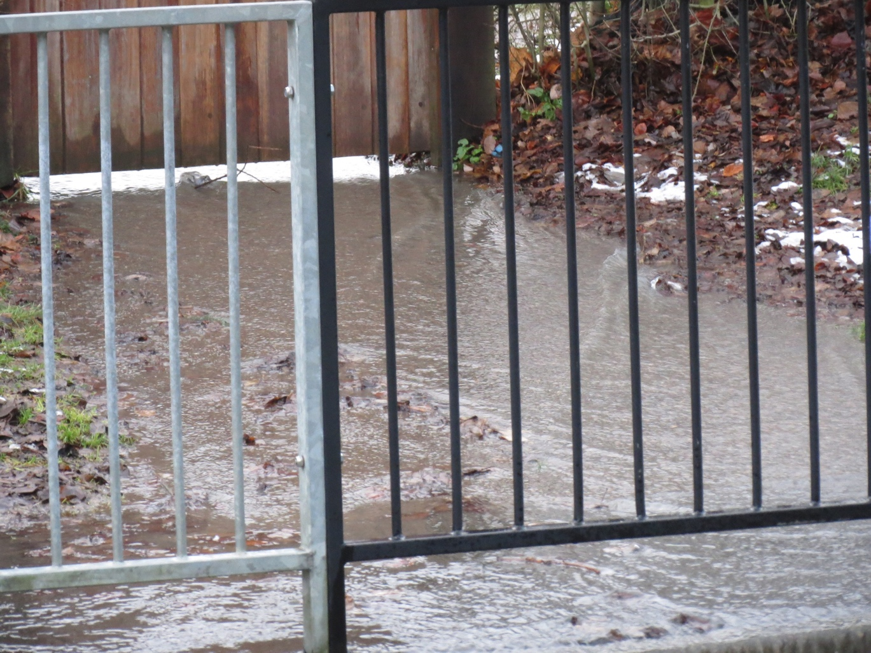
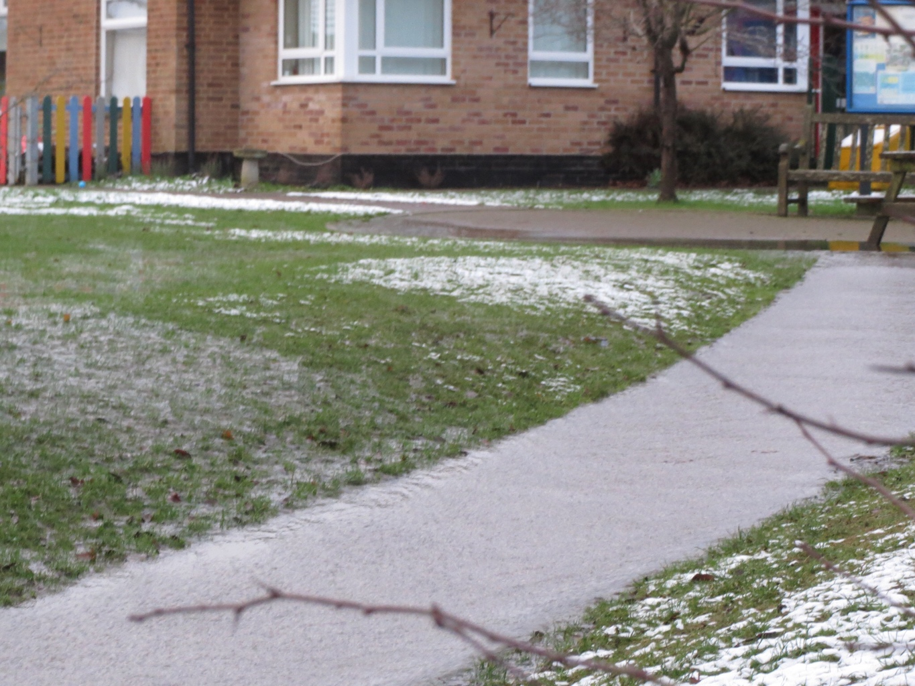
Picture 3: Water flowing under the school gate
Picture 4: Water flowing off of the school playing field and down the path

